**Scar Management**

A soft mobile scar will allow easier movement and will be more comfortable.

You can help your scar by:

* Deep massage using plain moisturiser for skin hydration 3-4 x daily.
* Massage in a circular motion around the scar or across the scar at right angles.
* Your therapist may provide silicon products if your scar is very thick or dry.

**Heat and Cold**

Cold weather can aggravate pain and stiffness. These strategies can help to prevent this:

* Wear a glove when outdoors. In winter this can also be helpful indoors.
* Use a hot water bottle or wheat bag to gently heat your hand before exercise to relax soft tissue and increase circulation.
* Resting your hand in warm water with a few drops of oil for 10 minutes will produce a similar heating effect.

Southern DHB 41165 V2

Issued 05/07/2016 Released 05/07/2016

**What is Dupuytrens?**

The exact cause of Dupuytrens is unknown. It may occur due to your genes and immune system, other risk factors including alcohol, diabetes and smoking may play a role, however their effects remain unclear. Dupuytrens is more common in people with Northern European ancestry and may run in your family.

Dupuytren’s contracture involves the deep fascia of the palm and the fingers. The fascia shortens and thickens, causing the fingers to be pulled into the palm.

Dupuytren's disease was first described in 1831 and is a common condition affecting males more than females at a ratio of 7:1.

The process is not dangerous, but continuously affects one or both hands, progressing slowly or rapidly at times, but can also have periods where no change is obvious.

The goal of surgery is to correct the contracture in the finger or palm. It will not cure the underlying condition. Recurrence after surgery is common and can occur in the same finger or others.

**Hand Therapy Service**

Physiotherapy Outpatient Department

Dunedin Hospital

Private Bag 1921 Dunedin

Telephone: (03) 470 9347

Facsimile: (03) 470 9921 / 59921

Physiotherapy Outpatient Department

Southland Hospital

PO Box 828 Invercargill

Telephone: (030 214 5740

Facsimilie: (03) 214 5779

# logo new

# Dupuytren’s Surgery

**Physiotherapy, Hand Therapy, Orthopaedic and**

**Plastic Surgery Services (District)**

**Patient Information**



**This pamphlet explains follow-up care after surgical release of Dupuytren’s contracture in your hand.**

Following Surgery

The goal is to make the most of your surgery therefore your surgeon will refer you to hand therapy or physiotherapy for rehabilitation.

NB: The fingers very rarely return to completely straight.

# Post-Surgical Goals

* Reduce swelling in your hand/fingers.
* Manage pain.
* Maintain the straightening of your finger gained by surger.
* Regain functional use of your hand through gentle exercise.
* Manage your scarring.

**Swelling**

* Some degree of swelling is normal.
* Reducing swelling makes it easier to bend and straighten your fingers.
* Elevation and gentle exercise can help to reduce swelling.

**Manage Post-surgical Pain**

* It is important that your hand isn’t in pain all of the time.
* Use pain relief as prescribed.
* If pain doesn’t improve then you should see your doctor.

**Night Splinting**

* Sometimes a hand splint is made to position your fingers comfortably and straighten them at night.
* The splint should continue to be used for 3 to 4 months after surgery.

**Wound Healing**

* It is important to keep your wound clean until it is completely healed to avoid infection.
* It is fine to wash your wound under running water when the dressing comes off, but do not soak the wound.
* Your therapist or a district nurse will redress your wound, sometimes hypafix tape is used to support the wound as it heals.

**Exercises**

* ‘Gapping’ in the wound as you get your fingers moving is OK.
* Exercise should be gentle and should not cause more pain or swelling.
* Passive exercise is good for this.
* ‘Ironing’ out your hand on a table top.
* Finger exercises.

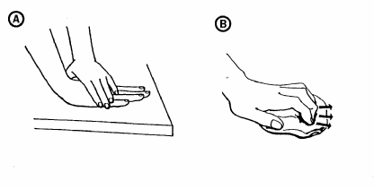

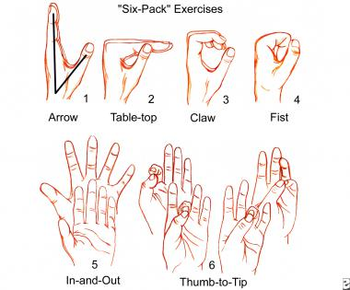

Exercise 10 times every 2 hours.

Once your wounds are healed, squeezing a light sponge or play dough can help to regain your grip.

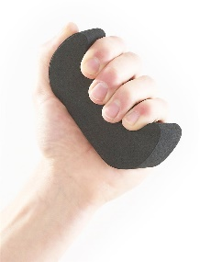

Squeeze and hold gently for 5 seconds, repeat 10 times 3 – 4 x daily.

You can return to light daily activities as soon as you are comfortable.

You can return to heavier tasks from four weeks post-surgery.

**Remember –** The aim is to regain your grip over 3 to 6 weeks, without causing swelling or pain.